**Student Projects Chapter 9 - Implementing Security Features for Student Projects**

Read the sample project steps for this chapter and apply the same techniques to the student project that you are developing. Use the normalized purely relational database you created at the end of chapter 6.

* Step 9.1 - Create a value-independent view that hides some private information.

The view will be of the Member table, but without address, email address or phone number.

CREATE VIEW MemberView AS

SELECT memberID, areaCode, firstName, lastName, zip

FROM Member;

* Step 9.2 - Create a user and authorize that person to read the view. Begin an authorization graph.

CREATE USER U1 IDENTIFIED BY SECRET1;

GRANT SELECT ON MemberView TO U1;

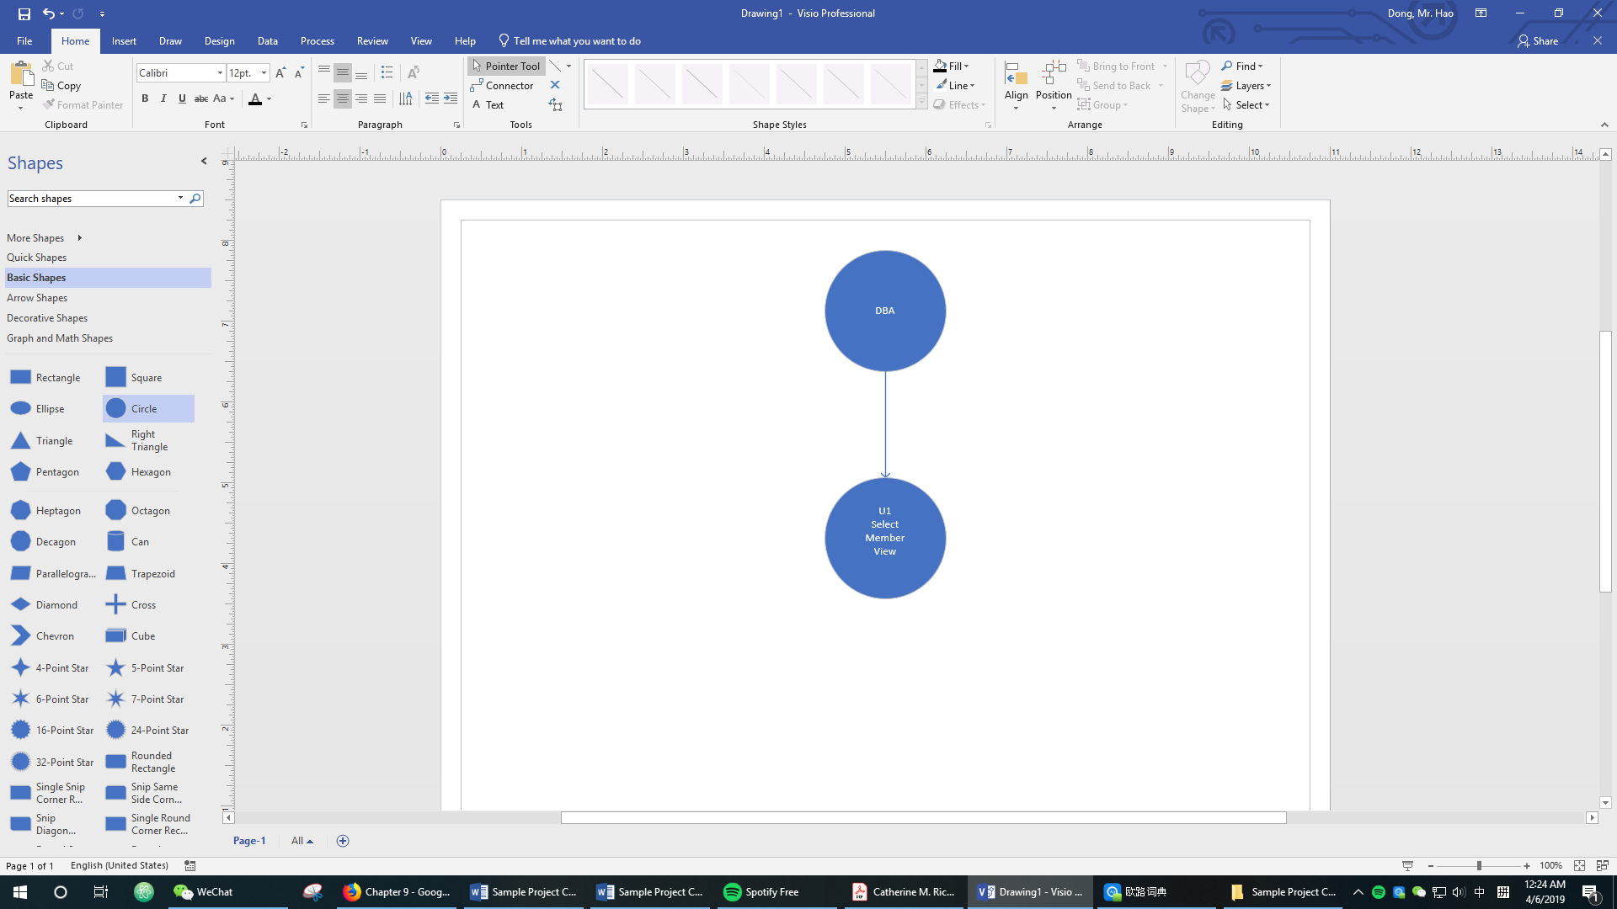

* Step 9.3 - Authorize four other users to access and/or modify various parts of the database, and update the authorization graph.

CREATE USER U2 IDENTIFIED BY SECRET2;

CREATE USER U3 IDENTIFIED BY SECRET3;

CREATE USER U4 IDENTIFIED BY SECRET4;

CREATE USER U5 IDENTIFIED BY SECRET5;

GRANT SELECT ON Subscriber TO U2;

GRANT ALL PRIVILEGES ON Member TO U3;

GRANT ALL PRIVILEGES ON MemberAudit TO U3;

GRANT SELECT, INSERT ON Performance TO U4 WITH GRANT OPTION;

GRANT ALL PRIVILEGES ON Donation TO U5;

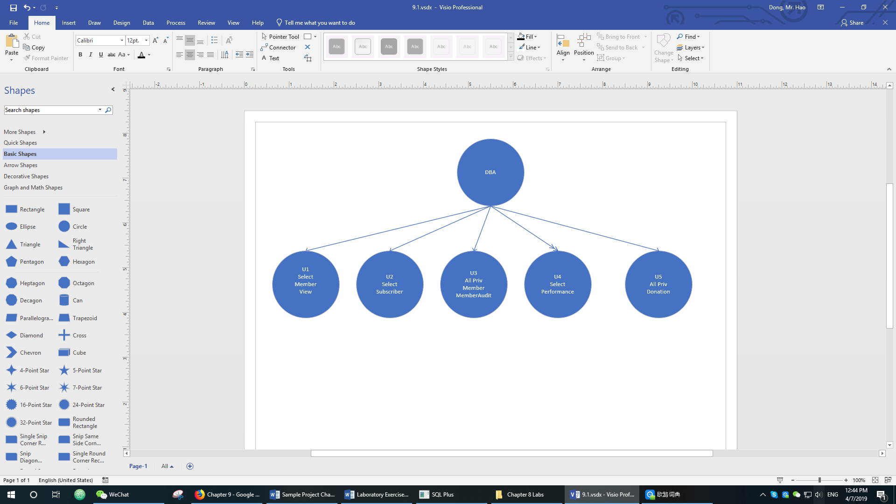

* Step 9.4 - Set up an audit trail for updates to a sensitive item that users can update and test it by updating the item.

*-- Creates a table to log the results of the audit trail*

CREATE TABLE MemberAudit(

dateOfUpdate DATE DEFAULT (sysdate),

userId VARCHAR2(30),

oldAddress VARCHAR(50),

newAddress VARCHAR(50)

);

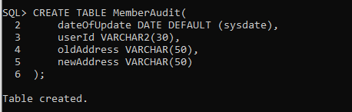

*-- Creates a trigger which creates a log entry whenever a user updates a member’s address*

CREATE OR REPLACE TRIGGER MemberAuditTrail

BEFORE UPDATE OF address ON Member

FOR EACH ROW

BEGIN

INSERT INTO MemberAudit

VALUES(SYSDATE, USER, :OLD.address, :NEW.address);

END;

/

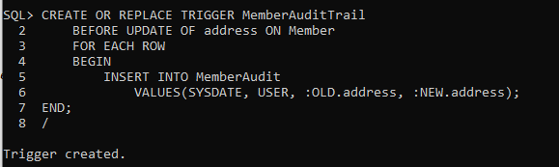

*-- Inserts the new member which will be used to test the audit trail*

INSERT INTO ZipCode VALUES ('10001', 'Manhattan', 'NY');

INSERT INTO Member VALUES('000055','45 West 20 St','718','[charlie@gmail.com](mailto:charlie@gmail.com)','Charlie','Fratturo','9434612','10001');

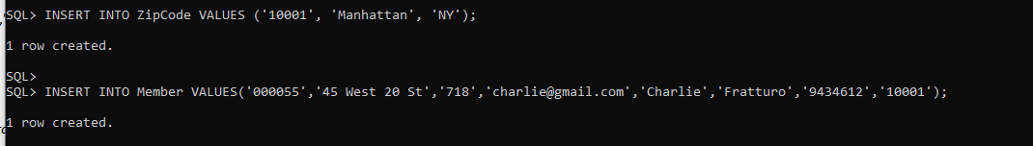

*-- Connect to U3 (has access to UPDATE any record in Member table)*

CONNECT U3;



*--test the trigger*

commit;

select address from system.Member;

savepoint original;

UPDATE system.Member set address = '60 West 20 St' WHERE memberID = '000055';

select address from system.Member;

select * from system.MemberAudit;

savepoint updated;

rollback to original;

select address from system.Member;

commit;